Week 2 Technical Article: Write an article titled "Understanding Your Data: The Essentials of Exploratory Data Analysis".

# Understanding Your Data: The Essentials of Exploratory Data Analysis

The algorithms and models that drive AI and ML systems don't inherently know what to learn; instead, they rely on the data provided to them. This process is akin to feeding a machine—if you provide it with poor-quality data, the results will likely be flawed as well.



Imagine you're a student being taught by an incompetent lecturer. Instead of gaining valuable knowledge and understanding, you might start picking up on their flawed methods, incorrect information, or poor teaching habits. Over time, this could lead to misunderstandings, gaps in your knowledge, and even the perpetuation of the lecturer's incompetence in your own learning.

Similarly, when training an AI model, if the data provided is full of errors, missing values, or irrelevant information, the model may learn incorrect patterns or pick up on noise—random variations that have nothing to do with the true relationship between the features and the target variable. As a result, the model's predictions will be inaccurate. This is why ensuring data quality is critical, and why Exploratory Data Analysis (EDA) is an essential practice.

EDA allows you to dive deep into your data, revealing insights that might not be immediately apparent. It helps you identify anomalies, understand the underlying patterns, and determine which features are most relevant for your analysis. Without EDA, you're essentially working with a black box, hoping for the best. But with EDA, you gain the knowledge needed to make informed decisions about your data, setting the foundation for a successful AI or ML project.

I'll walk you through the four most common steps in Exploratory Data Analysis (EDA), using a weather data analysis that I completed during a bootcamp. These steps are essential for gaining a deep understanding of your data, which in turn helps you make informed decisions when building machine learning models.

Key Steps in Exploratory Data Analysis

1. Data Cleaning Data cleaning is the foundational step where we handle missing values, remove duplicates, and correct errors in the data. Clean data is the first step toward building a reliable model. For instance, in our weather dataset, we might have encountered missing temperature values or inconsistent entries for wind speed. Correcting these ensures that our analysis is accurate and that our model learns from the best possible data.

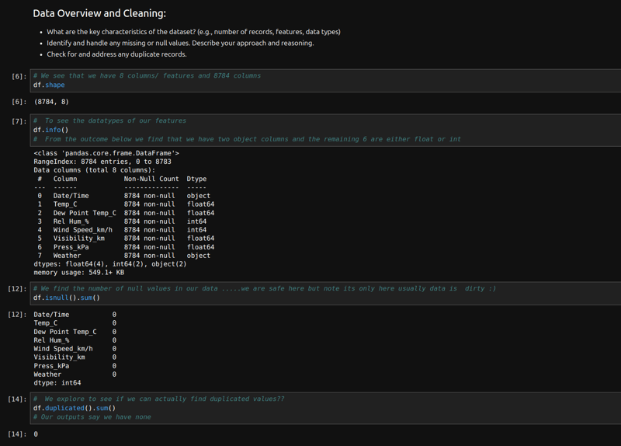

1. Data Visualization Visualizing data through charts, graphs, and plots is an effective way to understand distributions, relationships, and patterns in your data. Common visualizations include histograms, scatter plots, and box plots. In our weather analysis, visualizations like time series graphs for temperature or humidity can reveal seasonal trends or unusual spikes that might warrant further investigation.

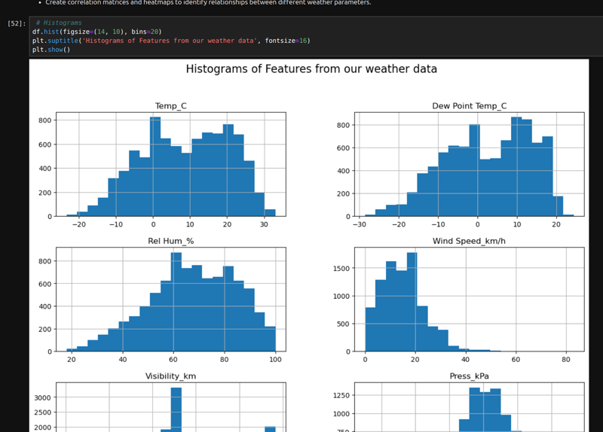

1. Statistical Analysis Statistical analysis involves calculating key statistical metrics such as mean, median, standard deviation, and correlation coefficients. These metrics provide insights into the central tendency, variability, and relationships between variables. For example, calculating the average wind speed and its standard deviation helps us understand typical weather conditions and their variability.

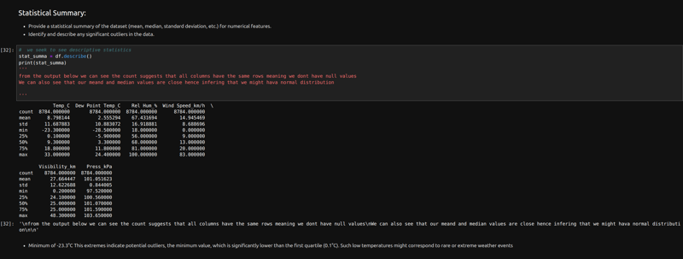

1. Outlier Detection Outliers are data points that differ significantly from other observations. Identifying and handling outliers is crucial because they can distort your analysis and lead to inaccurate models. For instance, if a weather station recorded an impossibly high temperature due to a sensor error, that outlier could skew your entire analysis if not addressed.

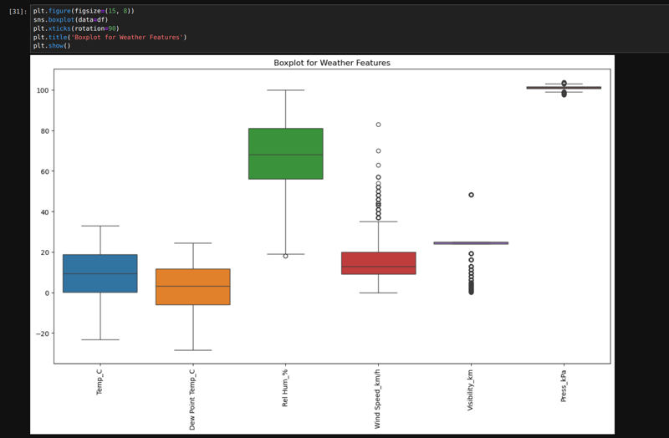

Conclusion  
In summary, Exploratory Data Analysis is the bedrock of any successful AI or ML project. By carefully analyzing and understanding your data, you ensure that your model is built on a solid foundation. Remember, the quality of your data directly impacts the quality of your model's predictions. So, before diving into the complexities of machine learning algorithms, take the time to thoroughly explore and understand your data—your model's success depends on it.

How to Prepare for a Data Analyst Interview in 2024.

Link: https://www.datacamp.com/blog/how-to-prepare-for-a-data-analyst-interview

7 Steps to Landing Your First Data Science Job.

Link: https://www.kdnuggets.com/7-steps-to-landing-your-first-data-science-job

Introduction to Data Engineering: A Complete Beginner’s Guide.

Link: https://medium.com/@TheWuraolah/introduction-to-data-engineering-a-complete-beginners-guide-0b955f5eb50c cc @channel